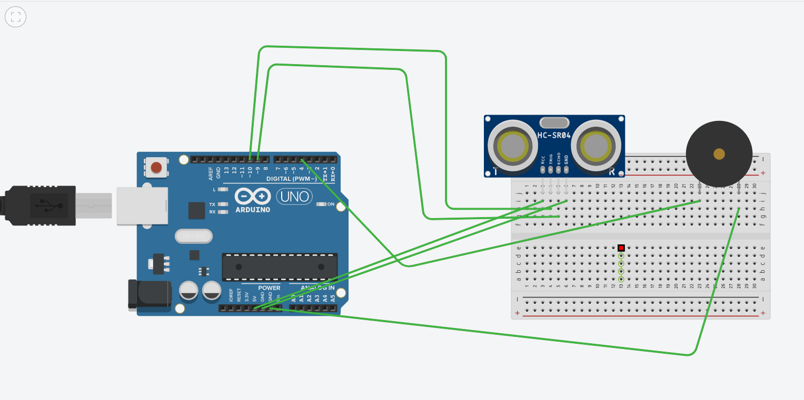**Q21 Design a system that automatically rings a bell for 2 ms whenever someone enters a temple, assuming only one person can enter at a time.**

**Theory**

here we have to take one ultrasonic hardware whose function is to sense the distance between the object .

one buzzer which will alarm in case of person entering temple.

**Problems and Trobleshooting**

Ultrasonic hardware make circuit complicated to run.

**Preacutions**

Be alert with the code

**Learning and outcomes**

Know more about ultrasonic hardware and future application based project related to this application.